Information Template
Step 3 – Public consultation on proposed subject matter

This template is for agencies to use for providing information to Te Kawa Mataaho Public Service Commission (the Commission) when undertaking Step 3 of the Long-term Insights Briefing (Briefing) process.

How Step 3 fits in the Briefing process
Step 3 involves public consultation on the proposed subject matter, as part of the eight steps in the Briefing process.

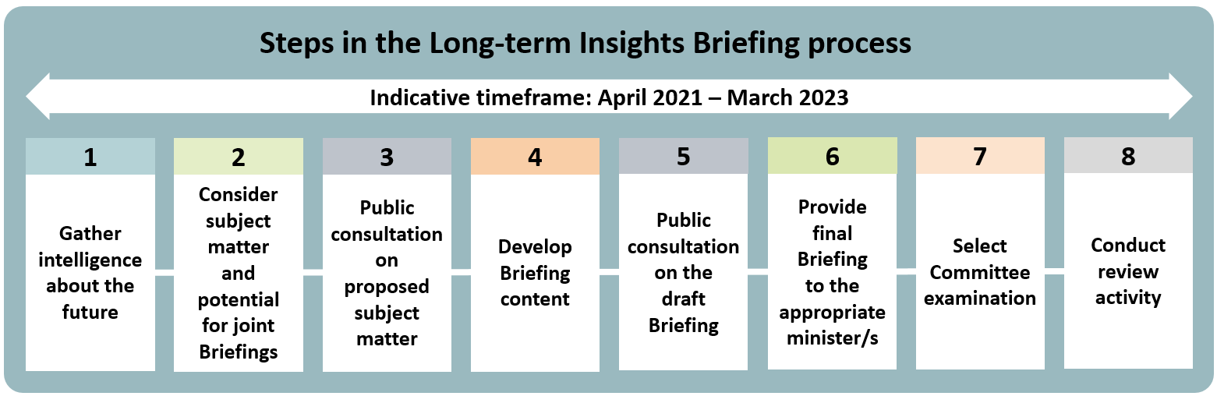
Guidance from the Department of the Prime Minister and Cabinet (available on their website) sets out the more detailed process for Step 3:
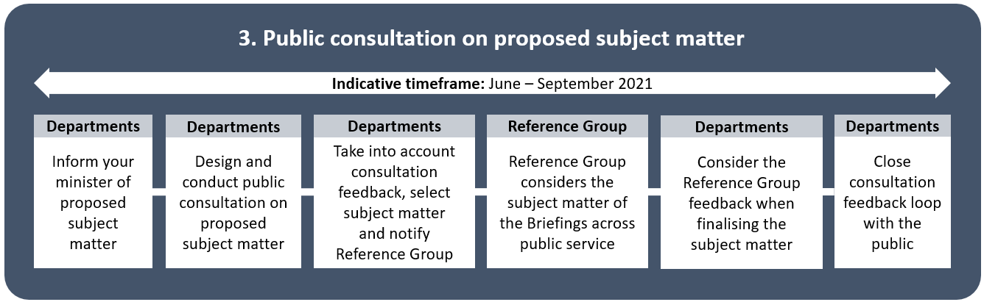

Using this template
To assist public consultation at Step 3, agencies are requested to fill out this template with the following information:
- agencies working on the relevant Briefing
- description of proposed subject matter/s
- dates for consultation
- a link to a page on your agency’s website with information about subject matter consultation.
Please fill in the information in the table below, then email this document to Te Kawa Mataaho’s Communications and Engagement Team with ‘Long-term Insights Briefing Website Content’ in the subject heading. Note that the information provided will be made available on Te Kawa Mataaho Public Service Commission’s website.

Agency name / joint agency names
Subject matter/s to be consulted on |  | (e.g. ‘The impact of technology x on issue y’)
Dates for consultation on proposed subject matter
Opening date:
Closing date:
Your agency’s webpage for consultation details
Any further information or notes

