Information Template
Publishing final Briefing
This template is for providing information to Te Kawa Mataaho Public Service Commission (the Commission) when agencies have provided their Long-term Insights Briefing (Briefing) to the appropriate minister during Step 6 in the Briefing process. The Commission will publish the information on their website after each Briefing is provided to Parliament.

How Step 6 fits in the Briefing process
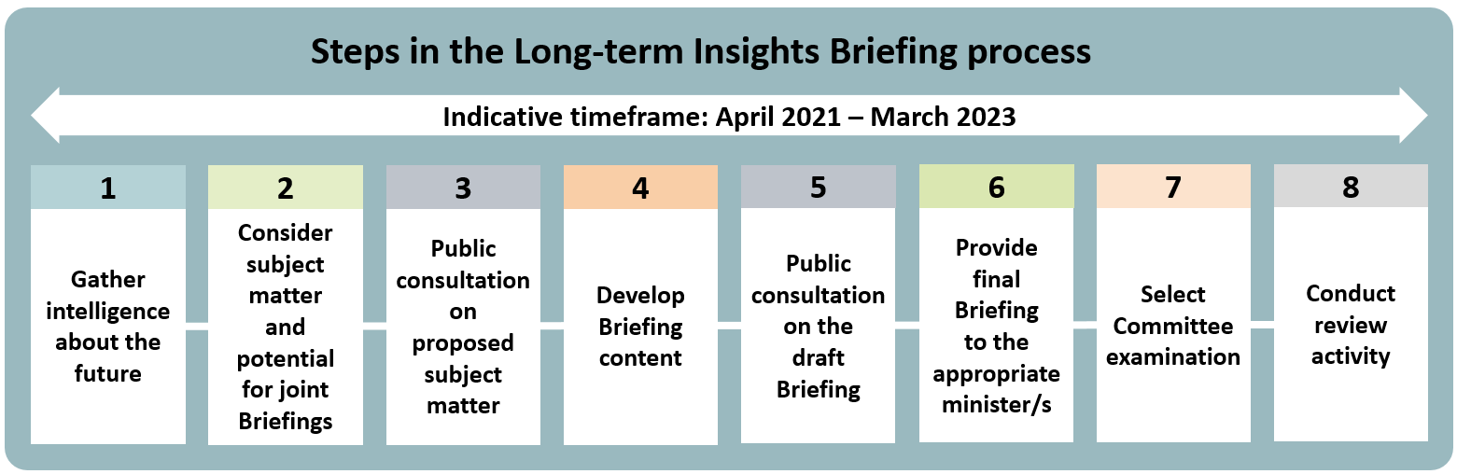
Guidance from the Department of the Prime Minister and Cabinet (available on their website) sets out the more detailed process for Step 6:
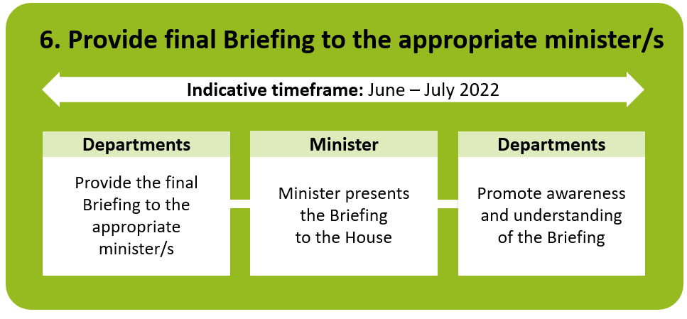

Using this template
This template should be completed after the appropriate Minister presents the Briefing to the House. Agencies are requested to fill out this template with the following information:
- a link to the final Briefing
- a link to a website with explanatory content about the Briefing, or any other information such as key messages
- details of any promotional events
Please fill in the information in the table below, then email this document to Te Kawa Mataaho’s Communications and Engagement Team with ‘Long-term Insights Briefing Website Content’ in the subject heading. Note that the information provided will be made available on Te Kawa Mataaho Public Service Commission’s website.

Agency name / joint agency names
Link to final Briefing on your website
Link to any other online content about the Briefings
Details of any promotional events
Any further information or notes

