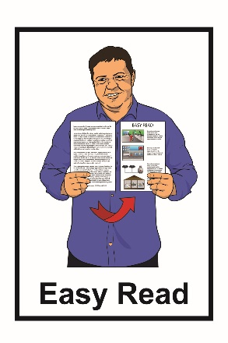
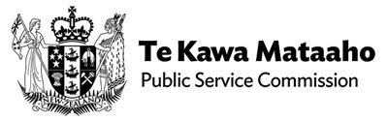

Announcing the Chief Executive of
Whaikaha – Ministry of Disabled People
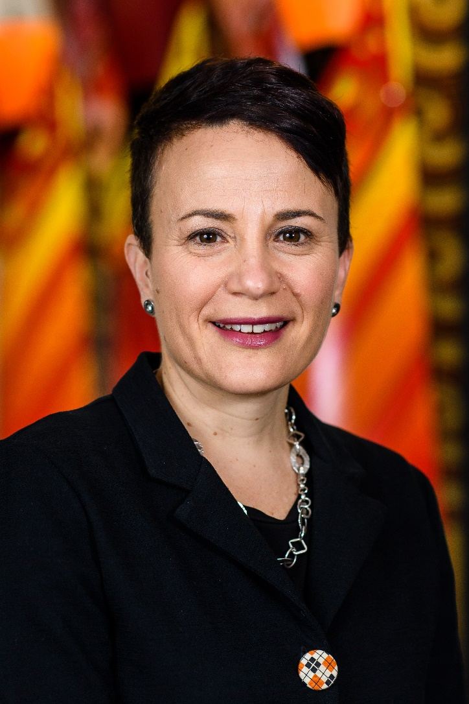

30 August 2022
What is this document about?

This Easy Read document:

- is about an announcement made by Te Kawa Mataaho Public Service Commission

- tells you about the Chief Executive for Whaikaha – Ministry of Disabled People.

Te Kawa Mataaho Public Service Commission:

- is a government department

- has been looking for a Chief Executive for Whaikaha Ministry of Disabled People.

A Chief Executive is someone who is in charge of an organisation.

Whaikaha – Ministry of Disabled People is a new part of the New Zealand government that will:
- use an Enabling Good Lives way of doing things
- work with other government agencies to better support disabled people
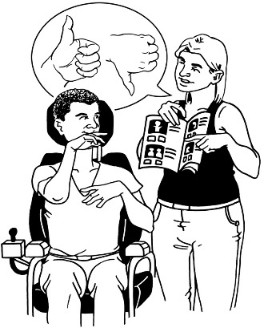
- make disability support services better for:
- disabled people
- family / whānau of disabled people.

The Chief Executive

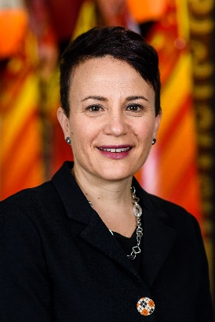
Ms Paula Tesoriero has been appointed as the Chief Executive of Whaikaha – Ministry of Disabled People.

Ms Tesoriero will start the role of Chief Executive from 1 September 2022.

Ms Tesoriero has been appointed to the role for the next 5 years.

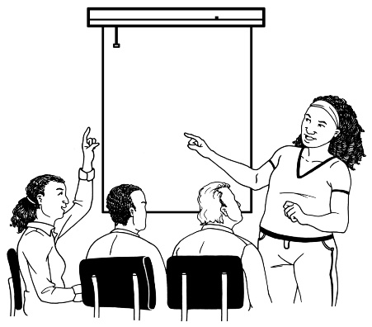
Ms Tesoriero is:

- a disabled person

- a well-known leader in the disabled community.

Ms Tesoriero is trusted by many:

- disabled people

- tāngata whaikaha Māori.

Since 2017 Ms Tesoriero has worked at the Human Rights Commission as the Disability Rights Commissioner.

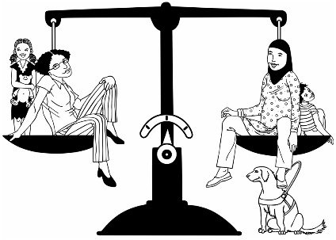
The Human Rights Commission makes sure that everyone in New Zealand is treated fairly.

The Disability Rights Commissioner works to protect the rights of disabled New Zealanders.

Ms Tesoriero has also worked at:
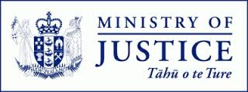
- the Higher Courts at the Ministry of Justice as the General Manager
- Statistics New Zealand as the General Manager of System and Partnership.
In 2022 Ms Tesoriero was appointed to the Asia New Zealand Foundation as an honorary advisor.

An honorary advisor means to:
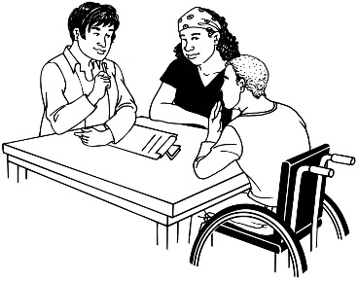
- be invited to have a position / role

- give advice to the Foundation about their work.

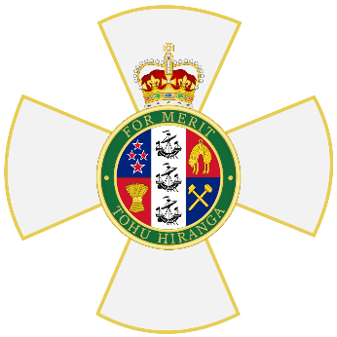
In 2009 Ms Tesoriero was made a Member of the New Zealand Order of Merit.

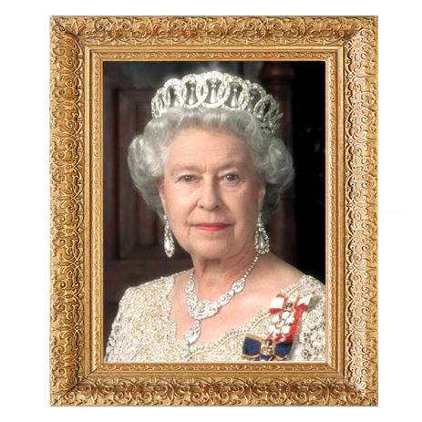
The New Zealand Order of Merit is a special award given by the Queen to people who have done very important things for New Zealand.

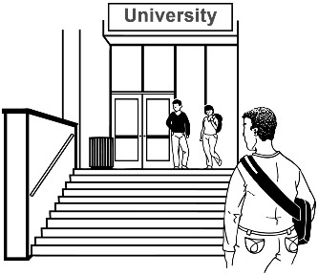
Ms Tesoriero studied at Victoria University where she did a:

- Postgraduate Diploma in Public Management

- Bachelor of Laws
- Bachelor of Arts.
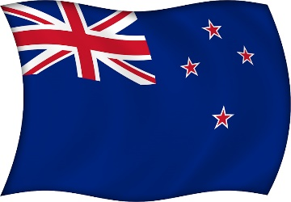
In 2008 Ms Tesoriero represented New Zealand as a Paralympian in the Paralympic Games.

A Paralympian is someone with a disability who competes in sports at the Paralympic Games.

The Paralympic Games is a big sports event where disabled athletes from all over the world compete.
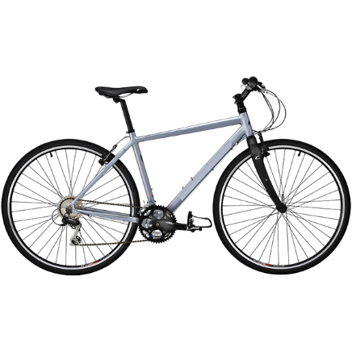

Ms Tesoriero competed in the Para cycling events.

In the Para cycling events she won:
- 1 gold medal
- 2 bronze medals.
In 2020 Ms Tesoriero was the Chef de Mission for the New Zealand team at the Tokyo 2020 Paralympic Games.
A Chef de Mission is the person who looks after the team while they are away.

Ms Tesoriero has had many roles like:
- Deputy Chair of Nuku Ora / Sport Wellington
- life trustee of the Halberg Disability Sport Foundation.

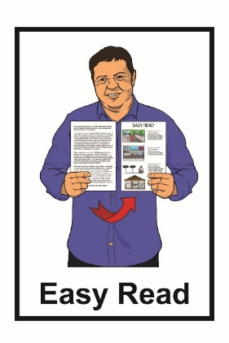
This information has been written by Te Kawa Maataho Public Service Commission.

It has been translated into Easy Read by the Make it Easy service of People First New Zealand Inc. Ngā Tāngata Tuatahi.

The ideas in this document are not the ideas of People First New Zealand Inc. Ngā Tāngata Tuatahi.
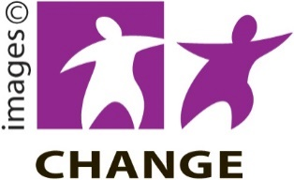
Make It Easy uses images from:

- Changepeople.org
- Photosymbols.com

- Sam Corliss
- Huriana Kopeke-Te Aho.

All images used in this Easy Read document are subject to copyright rules and cannot be used without permission.

