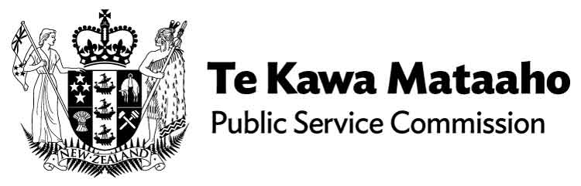

He Ārahitanga Pōtitanga Whānui | General Election Guidance 2023

Summary of guidance
The General Election Guidance 2023 covers what it means to work in the public sector before, during and after an election, for individuals and public sector agencies collectively. For a full list of who the guidance applies to, see: Who this guidance is for (https://tinyurl.com/48r7nnz9)
This document highlights some of the key topics covered in the full guidance. We encourage all to read the comprehensive version, see: General Election Guidance 2023 (https://tinyurl.com/4m5h6cjb)

Case studies
For examples of how to apply the principles set out in the guidance, see: Appendix A case studies (https://tinyurl.com/2akthpy7)

Public servants at work
When serving the government of the day, public servants must be politically neutral. This ensures the public sector maintains the trust and confidence of both current and future governments, and the public. For more information, see: Public servants at work (https://tinyurl.com/jjc7etya)

Public servants outside of work
Public servants have the same rights to freedom of speech and political activity in their private lives as other New Zealanders.
In general, there is nothing wrong in having political interests or activities outside work so long as these are identified and conflicts are avoided or appropriately managed. Public servants are expected to take reasonable care to maintain a clear separation between their work role and personal views.
If public servants have any uncertainties about how interests outside of work may impact their public sector role, we encourage them to refer to the full election guidance and to engage early with their agency to seek clarification.
If standing for election, public servants must separate their political candidacy from their work role and their agency. It is often appropriate for public servants to take a leave of absence during the campaign and for some this is a requirement from Nomination Day.
Board members who are thinking of standing for election are advised to discuss it with their Chair and monitoring department.
For more information, see Public servants outside work (https://tinyurl.com/4dxmf668)

Responsibilities of public sector agencies
The proactive release of Cabinet papers and responses to Official Information Act 1982 (OIA) requests continue as normal during the election period. All requestors should be treated the same, with MPs having the same rights as other New Zealanders, but no additional rights.
It is the responsibility of the chief executive to consider any risks to political neutrality before agreeing to or declining a visit from an MP.
It is never appropriate for an agency’s public funds or resources to be used for political purposes. Agency resources must not be used to display political material.
Unions may share their approach to party policies with members, but material must not be displayed in areas of an agency accessible by the public.
For more information, see Responsibilities of public sector agencies (https://tinyurl.com/2tdcaxjk)

Public sector advertising, publicity and the media
The Guidelines for Government Advertising apply at all times, including during the election period. Deferring some advertising in the pre-election period may sometimes be appropriate.
When corresponding with the media, agencies must take care to ensure that communications material is factual and politically neutral.
The nature and timing of programme launches and events must be carefully considered and managed to ensure the agency does not become drawn into any political aspects of an event. In some cases, it may be appropriate to defer high-profile events involving the Minister until post-election.
For more information, see: Public sector advertising, publicity and the media (https://tinyurl.com/msstjjdj)

The public sector and the General Election
The pre-election period is generally the three months immediately before election day. In 2023, the pre-election period begins on the 14th of July.
On election day, there is a ban on all political advertising, including social media. Public servants are strongly encouraged to vote. In 2023, the date of the general election is the 14th of October.
The caretaker convention applies from the day after election day until the new government is sworn in. For more information, see: The public sector and the general election (https://tinyurl.com/yk7skkma)

Government processes before, during and after an election
All requests by political parties for information to support the government formation negotiations must be made to the Public Service Commissioner. If an agency is requested to provide costings for information and analysis, the costings must be developed in consultation with The Treasury.
For more information, see: Government processes before, during and after an election (https://tinyurl.com/2yhjjxb8)
For more information or questions, please contact us at election@publicservice.govt.nz

End of information: He Ārahitanga Pōtitanga Whānui | General Election Guidance 2023

