


Information about the general election for people working in the public sector
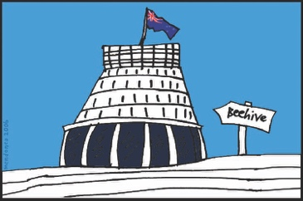



Published: February 2026

What you will find in here

Page number:


Important information about
website links 3


What is this document about? 4


Who this document is for 7


How public servants should act
while at work 10


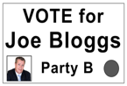
How public servants should act
when not at work 12

Page number:


How public sector agencies
should act 16
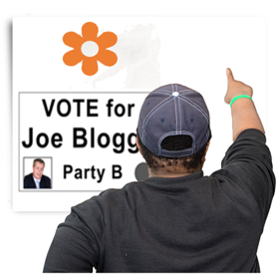

Advertising / media and public
sector agencies 19


The public sector and the
general election 23


Rules the government
must follow 25


How to find out more 27

Important information about website links


This document includes links to our website for more information.



These website links start with:

https://bit.ly


Bit.ly is a website that makes long website links:
shorter

easier to read
easier to share.


The links will send you to information that is not in Easy Read.

What is this document about?


This Easy Read document is a summary of a guide from the Public Service Commission.


A summary:
is shorter than the full guide
tells you the main ideas.

The Public Service Commission supports the Government to:

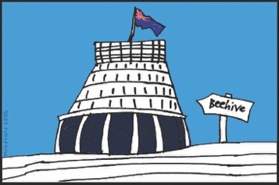
carry out its policies which are plans / rules for things the Government says it will do
make sure everybody in New Zealand can get the services they need.

This document is:
for people who are working in the public sector in New Zealand
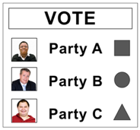

about how a general election might affect how they do their work.


The public sector is made up of many departments that look after services in different areas like:

housing
health services

justice
education.

In this document public means all the people New Zealand.

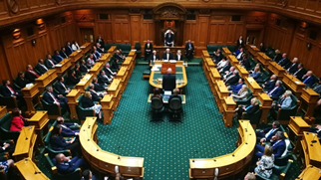
A general election is when people vote for who they want in Parliament.


When you vote you get to have your say about who you think should win an election.

Who this document is for

This document is for everyone in the public sector including:

the people who work in the public sector
agencies / organisations that work in / for the public sector.

A person who works in the public sector is called a public servant.


This document is a guide for how public servants should act:

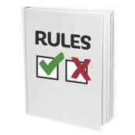
before an election
when an election is happening
after an election.

The time known as the pre-election period is usually the 3 months before election day.


Election day is the last day people can vote in an election.

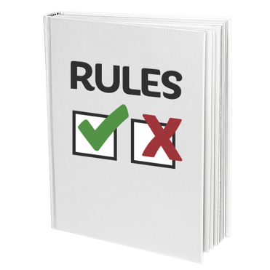
There are different rules that must be followed:
in the pre-election period
on election day.


You can find a full list of people for who this guide is for on our website at:

https://bit.ly/4kqvehw



You can also read the full guide document on our website at:

https://bit.ly/46IgRzr


The full document also includes some examples of how the guide might be used.


You can find these examples on our website at:

https://bit.ly/3Mq8CRH

How public servants should act
while at work

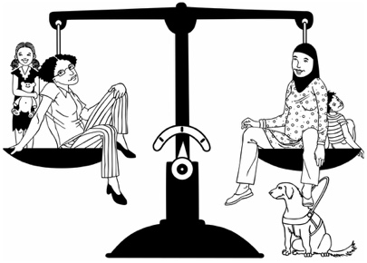
Public servants must always be politically neutral when doing their jobs.

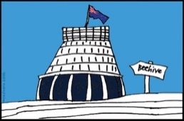

Politically neutral means that someone:
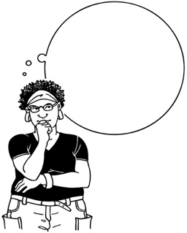
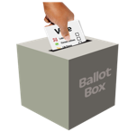
supports any government that has been elected
does not let their own politics / ideas affect their work.


Being politically neutral is a rule for everyone in the public sector.


This includes agencies that work in / for the public sector.

The public sector must stay politically neutral so they are trusted to do good work by:
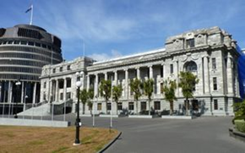
the public
any government.

You can find more information about how public servants should act at work on our website at:

https://bit.ly/3O8bWle

How public servants should act
when not at work

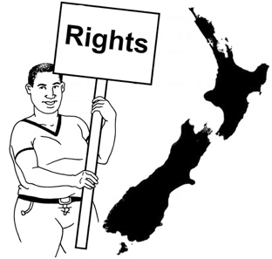
Public servants have the same rights as other people in New Zealand.

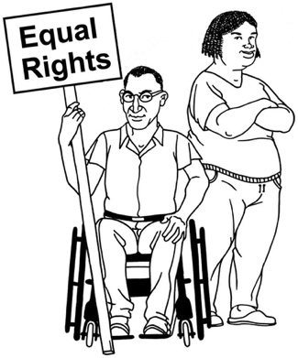
Rights are things that everyone has that say what a person can do / have like:

- the right to think / say what they think about things that are important to them
- the right to have ideas / views without someone else trying to stop / change them.
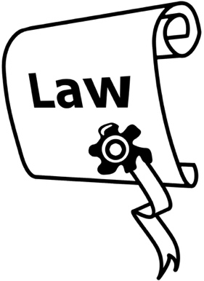

Some rights are also made into laws so they cannot be taken away.
Public servants have the right to support the political party they choose.

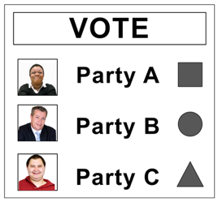

It is okay for public servants to have interests in politics outside of their work.

These interests must not affect how they do their jobs.


Public servants who are standing for election must not let this affect their work.


The people you vote for in an election are called candidates.


When someone says they want to be a candidate it is called standing for election.


A public servant who is standing for election must take time off work:
- from nomination day

or
- before this day if being a candidate might affect their work in a way that means they cannot be politically neutral.


Nomination day is usually about a month before election day.

You can find more information about how public servants should act when not at work on our website at:
https://bit.ly/4qxo24T

How public sector agencies should act

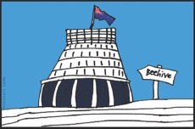
Most public sector agencies will carry on doing their jobs as usual during election time including:

publishing documents that come from the government / Parliament
answering questions asked as part of the Official Information Act.

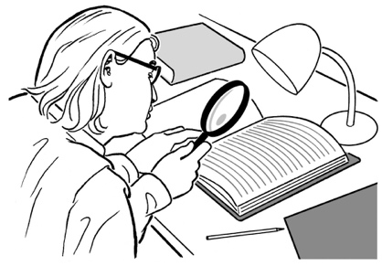
The Official Information Act gives the public the right to look at information that the government has.

Everyone has the equal right to ask for this information including Members of Parliament called MPs.

The person who leads the public sector agency is called the chief executive.

The chief executive must make sure the agency is always politically neutral.



This includes if / when an MP visits the public sector agency.


Any public money / funding that the agency has cannot be used for political reasons.

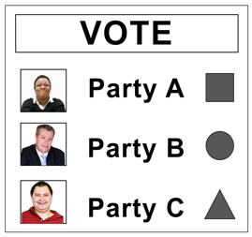
The agency must also not display any political material such as posters / other campaign information.
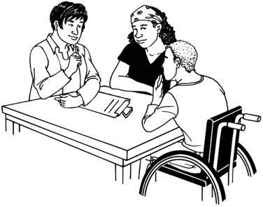

Some agencies have a union.

A union is an organisation that supports people at work by speaking up for them.



It is okay for the union to share what they think about party policies with members.
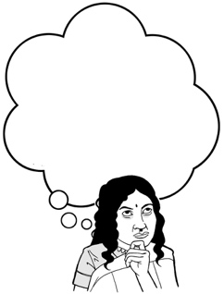

Party policies are what political parties think about different subjects.

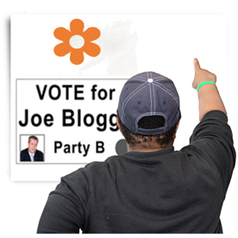
Information about party policies from a union cannot be put in a place where people who do not work there can see / read it.

You can find more information about how public sector agencies should act on our website at:

https://bit.ly/4kwTv5I

Advertising / media and public sector agencies


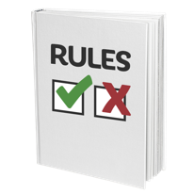
There are rules about government advertising that must always be followed including during election time.

Government advertising is when material like a poster or video is made to share information that the public needs to know.

You can read the rules about advertising on our website at:

https://bit.ly/4tB1eUz

It might be a good idea to leave some kinds of advertising until after the election.

No one is allowed to do political advertising anywhere on election day.



This includes advertising on social media like:
Facebook
X / Twitter.


Public sector agencies must make sure everything they say to the media is:
- true
- politically neutral.


The media reports on what is happening through things like:

news programs on TV

news / information on the internet

newspapers
local radio.


Public sector agencies must make sure any new events do not happen at a time that makes them seem like they are trying to tell people to vote in a certain way.


It may be better to leave some kinds of events until after the election.

You can find more information about advertising / media and public sector agencies on our website at:

https://bit.ly/4rleDhG

The public sector and the general election



A rule called the caretaker convention is followed:
from the day after election day
until the new government takes over.

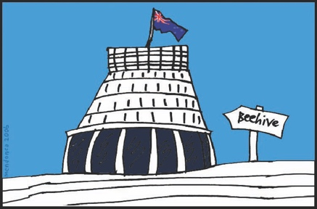
The caretaker convention means that the previous government carries on working in Parliament until the new one takes over.

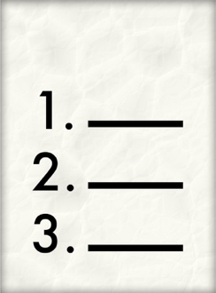

Previous means something that has come / happened before.

The previous government:
still has the same powers / responsibilities it had before the election
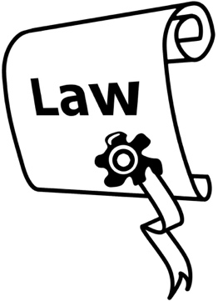
but
does not usually use them to make changes.

You can find more information about the public sector and the general election on our website at:

https://bit.ly/4aIXl8s

Rules the government must follow


When a new government is being put together political parties may want information from / about the public service.


Political parties must ask the Public Service Commissioner for any information they want.


The Public Service Commissioner
leads the public sector to make sure all the departments work well together.

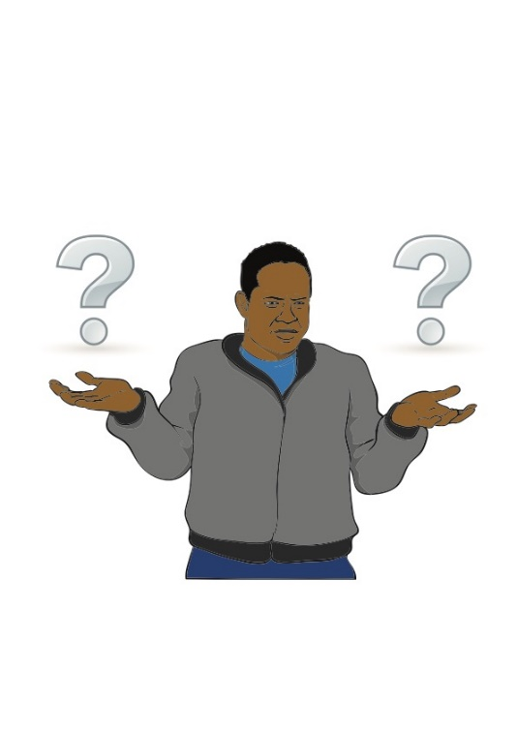

A public sector agency may be asked to give information about how much money it has spent on services to the public.

The public sector agency must work with the Treasury to put this information together.
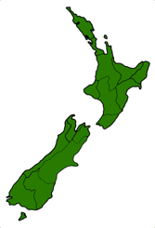


The Treasury is the government department that looks after how much money New Zealand has.

You can find more information about the public sector and rules the government must follow on our website at:

https://bit.ly/4arazWg

How to find out more information

You can get in touch with us if you:
- need more information
- want to ask us any questions.


You can send us an email to:
election@publicservice.govt.nz


You can read the full guide document on our website at:
https://bit.ly/4kqvehw


This information has been written by
Public Service Commission.


It has been translated into Easy Read by the Make it Easy Kia Māmā Mai service of People First New Zealand Ngā Tāngata Tuatahi.

The ideas in this document are not the ideas of People First New Zealand Ngā Tāngata Tuatahi.

All images used in this Easy Read document are subject to copyright rules and cannot be used without permission.


Make it Easy uses images from:


- Photosymbols

- Change Images

- Huriana Kopeke-Te Aho


- SGC Image Works

- T Wood


- Studio Rebeko

- Inga Kramer.

